**Project Research**

We are using reacts.js which is a javascript library and php as a server side scription language and sql as a database.

We have researched on how to add a react in existing html website and how to connect the react with the php. To add react in html we have to add scripts for rendering DOM, load react.

<script src= "https://unpkg.com/react@16/umd/react.production.min.js"></script>

<script src= "https://unpkg.com/react-dom@16/umd/react-dom.production.min.js"></script>

<script src="https://unpkg.com/babel-standalone@6.15.0/babel.min.js"></script>

Most of the time developers use JSX which is mixture of html and javascript.it is easy to write and can also work as a inline php.

React has some components of UIs which we can use and it takes parameters like props.

Render method renders what you want to see on the screen.

To install reacts u must have the node.js in your computer.

We can add react in a small part of website and can be gradually expand its presents.

<https://reactjs.org/tutorial/tutorial.html>

<https://www.w3schools.com/whatis/whatis_react.asp>

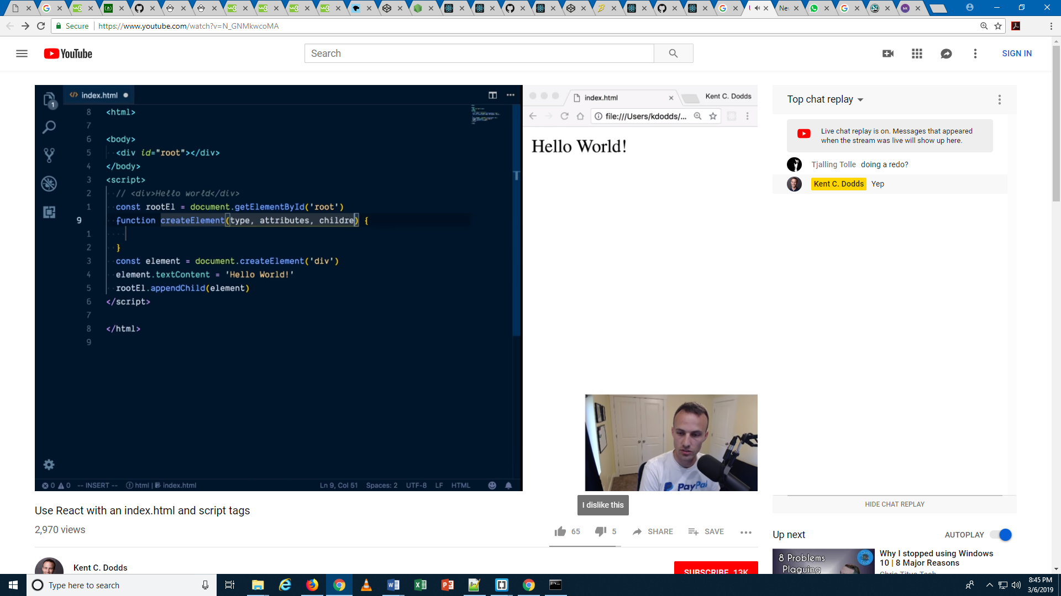

<https://medium.freecodecamp.org/learning-react-roadmap-from-scratch-to-advanced-bff7735531b6>

<https://egghead.io/courses/the-beginner-s-guide-to-react>

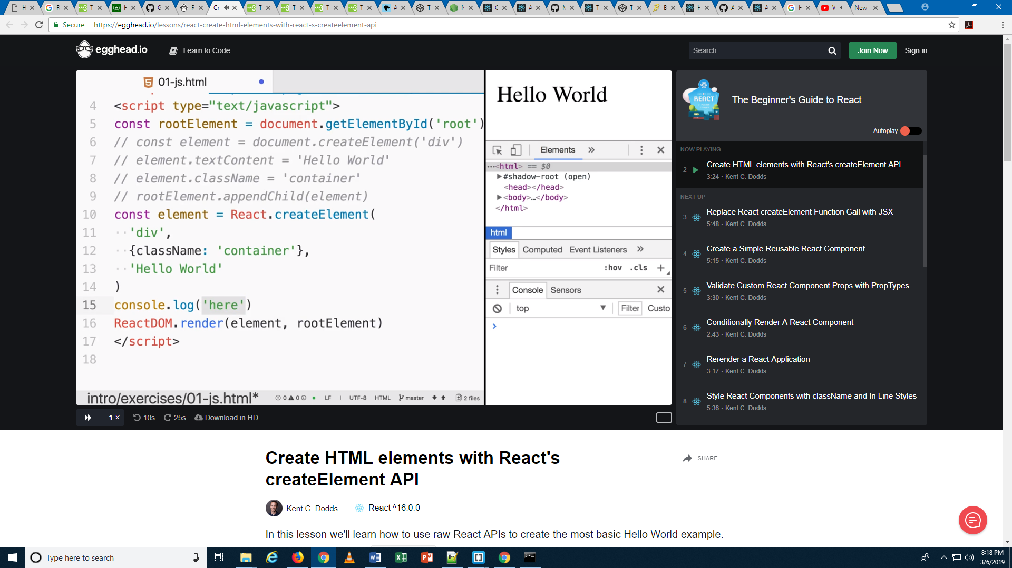

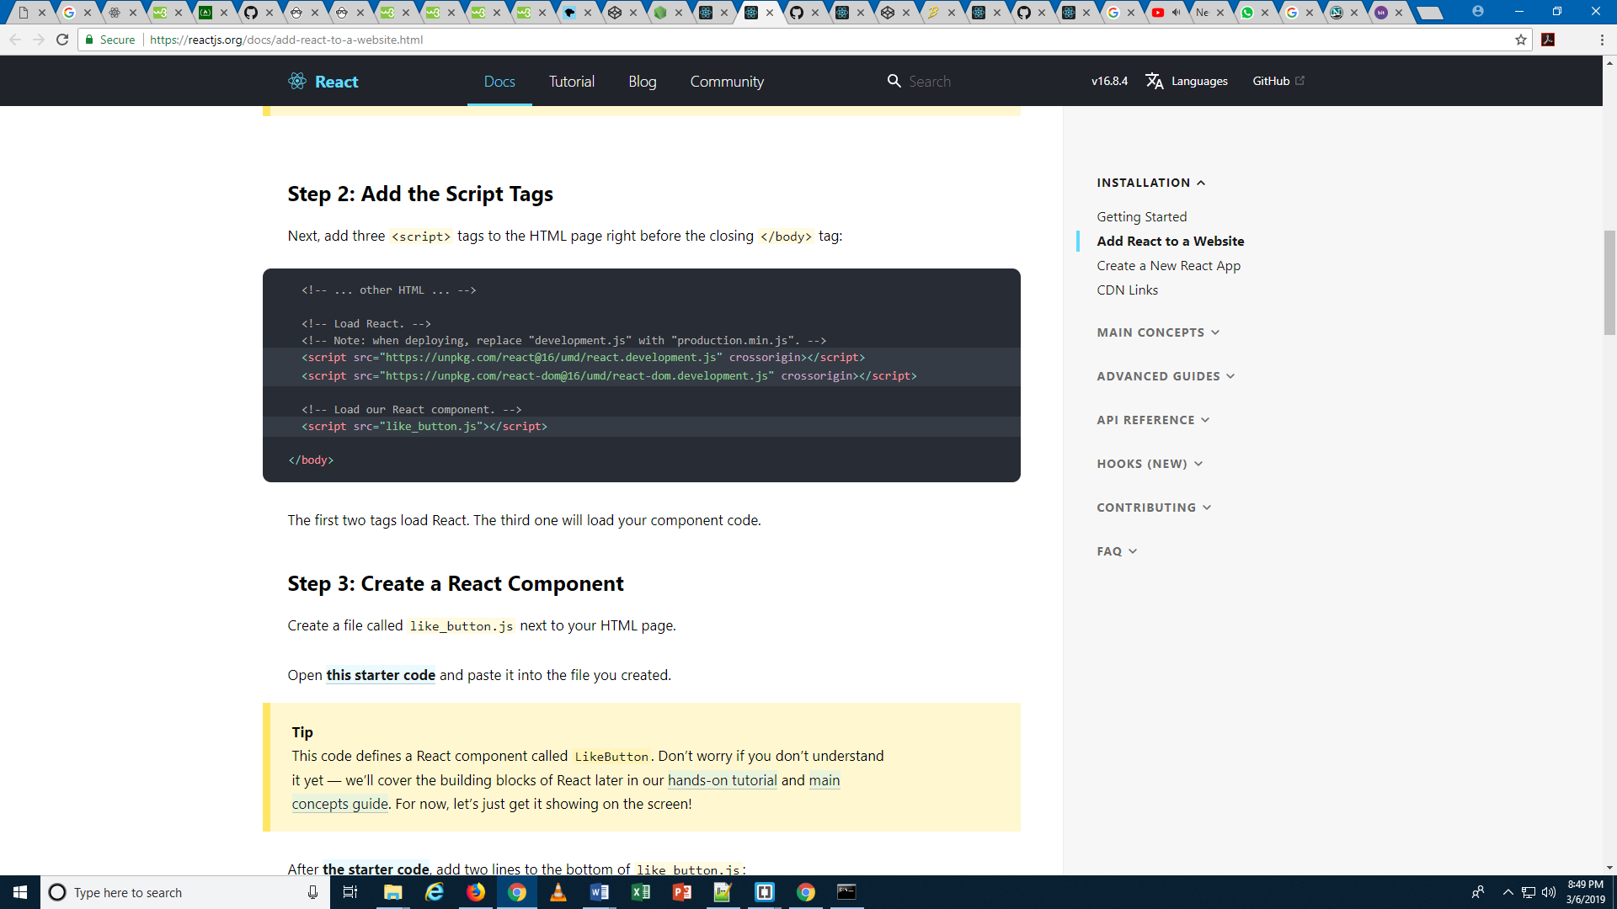

There is a sample code wich I have tried to create with react in html.